Matrices = matrix复数 = 矩阵

2D = two-dimensional

6 by 4 array = 6 rows and 4columns

3D:

2 page 6 by 4 by 2

Pi = 3.1416

>> X = [1 2 3;3 4 5]

X =

1 2 3

3 4 5

矩阵

Size(X)

Ans = 2 3 (2by3)

Y = 5

Size(Y) = 1 1

Sin(30) and sind(30)

-0.9 0.5

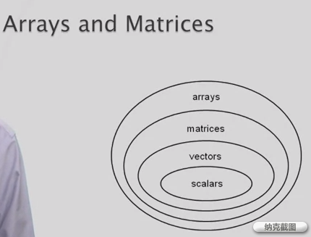

Array 数组

Matrices 矩阵

Vector 矢量向量 row vectors or column vectors

Scalar 数量标量 numbers

**Colon operator**

>> x = 1:3:7 1:-3:7 负数也可

x =

1 4 7

从1开始，3为公差，不超过7

>> ints = 1:30

ints =

1 至 19 列 columns 1 through 19

1 2 3 4 5 6 7 8 9 10 11 12 13 14 15 16 17 18 19

20 至 30 列

20 21 22 23 24 25 26 27 28 29 30

>> size(ints)

ans =

1. 30 (一个row 30个数（column）)

1 + 2 = plus(1,2)

>> x = [1:3;4:6;7:9]

x =

1 2 3

4 5 6

7 8 9

>> y = x(2,2)

y =

5

可以改变矩阵

>> x(2,2) = 10

x =

1 2 3

4 10 6

7 8 9

>> x(4,4) = 11

x =

1 2 3 0

4 10 6 0

7 8 9 0

0 0 0 11

>> x(2,[1,2])

先读取2行的1列，然后2列

ans =

4 10

>> x([1,2,3],[1,2,3])

一行1，2，3列；二行1，2，3……..

ans =

1 2 3

4 10 6

7 8 9

>> x(2:-1:1,3:-1:1)

第二行 3列2列减一到1列 减一到第一行……

ans =

6 10 4

3 2 1

>> x(end,2)

最后一行第二列

ans =

0

>> x(4,end-1)

倒数第二列

ans =

0

X(1:end,2) = X(:,2)

>> x (1:end,2)

ans =

2

10

8

0

>> x (1:end,2) = 44

改变矩阵

x =

1 44 3 0

4 44 6 0

7 44 9 0

0 44 0 11

>> x (1:end,2:4) = 44

x =

1 44 44 44

4 44 44 44

7 44 44 44

0 44 44 44

>> x (1:end,2:4) = [10 20 30;20 30 40;30 40 50;40 50 60]

（）矩阵选取 【】建立矩阵

x =

1 10 20 30

4 20 30 40

7 30 40 50

0 40 50 60

>> xyz(2,2) = 122

xyz =

0 0

1. 122

**Combining and Transforming Matrix**

>> A1 = [1 1 1;1 1 1;1 1 1]

A1 =

1 1 1

1 1 1

1 1 1

>> A2 = [2 2 2;2 2 2;2 2 2]

A2 =

2 2 2

2 2 2

2 2 2

>> A3 = [3 3 3;3 3 3;3 3 3]

A3 =

3 3 3

3 3 3

3 3 3

>> hengzhe = [A1 A2 A3]

hengzhe =

1 1 1 2 2 2 3 3 3

1 1 1 2 2 2 3 3 3

1 1 1 2 2 2 3 3 3

>> shuzhe = [A1;A2;A3]

shuzhe =

1 1 1

1 1 1

1 1 1

2 2 2

2 2 2

2 2 2

3 3 3

3 3 3

3 3 3

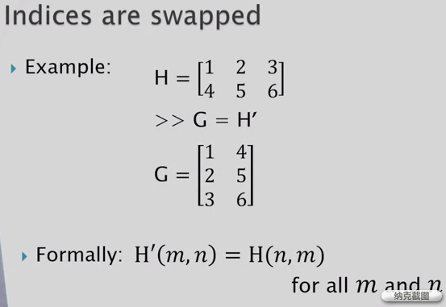

>> 1:2:5

ans =

1 3 5

>> 1:2:5'

实际上’的是5

ans =

1 3 5

>> (1:2:5)'

加（）

ans =

1

3

5

